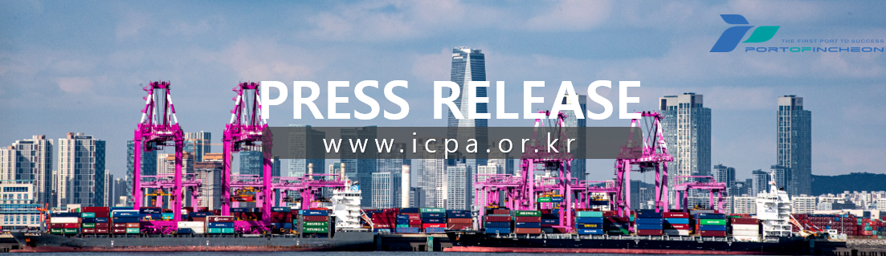
Incheon Port Exceeds 3 Million TEUs in Container Volume...Expected to Set a New Record for Highest Volume Following Last Year’s High
/ Achieved 3 Million TEUs as of November 6, Shortening the record by 11 Days Compared to Last Year’s Achievement Date

<Container volume is based on the initial tally of results as of November 6, and
may be subject to adjustments in the final tally>

- The Incheon Port Authority (www.icpa.or.kr, President Lee Kyung-Gyu) announced that as of November 6, Incheon Port's container volume surpassed 3 million TEUs, setting a new record for achieving this milestone in the shortest time frame.

- According to IPA, the previous record for reaching 3 million TEUs was November 17th last year while this year's achievement came 11 days earlier. In addition, Incheon Port has maintained a container volume of over 3 million TEUs for eight consecutive years since 2017.

- Despite significant challenges, both domestic and international, such as sluggish domestic consumption, increased volatility in shipping rates due to the worsening Middle Eastern conflicts, and a decline in used vehicle shipping volumes compared to last year, Incheon Port's overall cargo volume increased across all sectors, including imports, exports, and transshipments.

- Export volumes showed significant growth in various sectors such as machinery, miscellaneous goods, textiles, and plastic/rubber products. On the other hand, imports showed notable increases in categories such as electronics, timber, plastic/rubber products, and miscellaneous goods.

- This year, IPA attracted new export volumes in office furniture, agricultural products (paprika), and e-commerce through its port sales initiatives in collaboration with overseas offices in Shanghai, and Ho Chi Minh City, among others.

- Moreover, IPA revitalized its global port sales activities which had been challenging to pursue since the COVID-19 pandemic. Incheon Port’s new logistics environment and capabilities were actively promoted not only in China, Vietnam, and Singapore but also in Germany and France.

- IPA will collaborate with container operators and shipping lines to intensify marketing efforts aimed at shipping companies and cargo owners, in efforts to achieve this year’s goal of 3.5 million TEUs by year-end.

- Incheon Port Authority's President Lee Kyung-Gyu stated, “Despite global supply chain disruptions and sluggish domestic demand, we successfully increased Incheon Port’s cargo volumes through close collaboration with logistics partners, including shipping companies, freight forwarders, and container operators utilizing Incheon Port”, and added, “In the coming year, we aim to lay a solid foundation for sustainable cargo volume growth by enhancing container volumes and routes between Korea and China, strengthening port sales efforts targeting ‘Next China’ regions such as India and Indonesia, and expanding cargo marketing initiatives in the central region.”

Reference |  | Status of Incheon Port Container Volume

□ Yearly Achievement Date of 3 million TEUs at Incheon Port
Category | 2017 | 2018 | 2019 | 2020 | 2021 | 2022 | 2023 | 2024
Date Achieved | December  27 | December  18 | December  21 | December  2 | November 24 | December  10 | November 17 | November 6

□ Incheon Port Import/Export Volume (Cumulative Preliminary Figures as of October 2024)
(Unit : 1000 TEUs, %)
Category | October 2023  (Cumulative) | October 2024  (Cumulative) | Amount of Increase | Rate of Increase
Total | 2,829 | 2,952 | 123 | 4.4
Imports | 1,422 | 1,472 | 50 | 3.6
Exports | 1,369 | 1,437 | 68 | 5.0
Transshipments | 37 | 43 | 6 | 16.2

