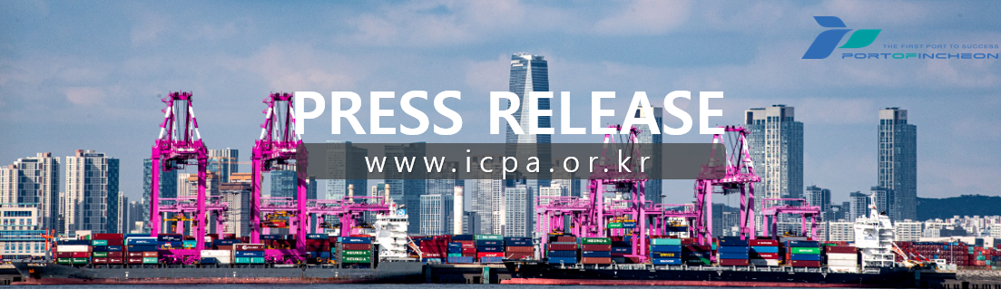
IPA Signs Implementation Agreement for Phase 1-2 of the Incheon New Port Container Terminal Project

IPA and IGCT Host Signing Ceremony, Committing to launch in December 2027

- The Incheon Port Authority (www.icpa.or.kr, President Lee Kyung-Gyu) announced on the 12th that it has signed an implementation agreement with the (tentative) Incheon Global Container Terminal Co., Ltd.* (hereinafter, IGCT), the preferred bidder for the Phase 1-2 container terminal project at Incheon New Port. The signing ceremony was concluded at The Plaza Hotel Seoul (119, Sogong-ro, Jung-gu, Seoul).
* Consortium Participants: Hanjin Co., Ltd., Sun Kwang Co., Ltd., E1 Corporation, Korea Marine Transport Co., Ltd., and HMM Co., Ltd.

- The implementation agreement signing ceremony was attended by Incheon Port Authority President Lee Kyung-Gyu, ▴Hanjin Co., Ltd. CEO Noh Sam-seok, ▴Sun Kwang Co., Ltd. CEO Lee Do-hee, ▴Korea Marine Transport Co., Ltd. CEO Shin Yong-hwa, ▴HMM Co., Ltd. CEO Kim Kyung-bae, and ▴E1 Corp Managing Director Kim Sang-hoon. The attendees mutually confirmed their commitment to faithfully execute the project in accordance with the contents of the implementation agreement.

- Phase 1-2 Container Terminal at Incheon New Port is set to open in 2027, initially featuring three berths (Zone A, 1,050m), which will provide an annual handling capacity of 1.38 million TEUs. This development is expected to increase Incheon Port’s total container handling capacity to 4.08 million TEUs.

- Subsequently, to accommodate the increase in growing cargo volume, one additional berth (Zone B, 350m) will be developed, with IGCT managing both Zones A and B as an integrated operation.

- Incheon Port Authority's President Lee Kyung-Gyu remarked, “We anticipate that through the automation of the Incheon New Port Phase 1-2, Incheon Port will be able to solidify its position as a major global port.” and added, “We will do our utmost to successfully implement the project and achieve the goal of handling 5 million TEUs of container cargo by 2030.”

- For inquiries, contact the IPA Logistics Strategy Office (☎032-890-8215/8207)

- Photo Caption
= Signing of implementation agreement and taking a photo
(From left to right: E1 Corporation Managing Director Kim Sang-hoon, Sun Kwang Co., Ltd. CEO Lee Do-hee, Incheon Port Authority President Lee Kyung-Gyu, Hanjin Co., Ltd. CEO Noh Sam-seok, Korea Marine Transport Co., Ltd. CEO Shin Yong-hwa, and HMM Co., Ltd. CEO Kim Kyung-bae)

/ Photo provided by the Incheon Port Authority

