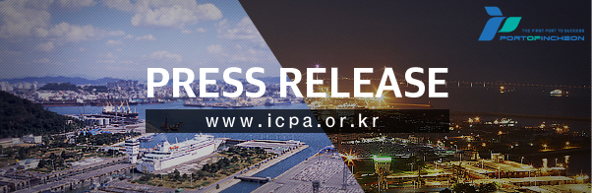
Incheon Port with 16.1% increase of container volume in August compared to the previous year

[September 27th, 2017, Incheon, Republic of Korea]

○ Incheon Port has processed 254,000 TEU last month, renewing its record for the biggest container volume for 18 consecutive months.

○ Incheon Port Authority (www.icpa.or.kr, CEO Nam Bong Hyeon) revealed on the 27th that it has recorded 254,000 TEU last month, the highest ever in the August container volume. This is a 16.1% increase compared to the 219,291 TEU last year.

○ According to Incheon Port Authority (IPA), such renewal of the highest record of monthly container volume is being continued for 18 months until the last month since the opening of Incheon New Port’s Hanjin Incheon Container Terminal (HJIT).

○ Last month’s import container volume was 129,058 TEU which was an increase of 14,810 TEU compared to the same month in the previous year, taking up 50.7% of the total quantity. As for export, it was 123,556 TEU which is an increase of 20,522 TEU compared to the same month in the previous year. As for transshipment and coastal container volume, they were 1,244 TEU and 633 TEU respectively.

○ As per country, trade amount to China recorded 152,813 TEU which is an crease of 21.4% compared to 125,841 TEU in the previous year and the trade amount to Iran attracted attention with 6,318 TEU, a 175.1% increase. In addition, the trade amount to Thailand of 9,091 TEU in the same month of the previous year recorded 12,031 TEU showing an increase of 32.3%.

○ According to IPA, the top 5 countries with the highest annual container volume during the past 5 years were China, Vietnam, Thailand, Taiwan and Hong Kong. As for China, the annual average increased by 7.3% from 1.203,000 TEU in 2012 to 1.596 TEU last year. Vietnam showed an increase rate of 25.6% from 97,000 TEU in 2012 to 242,000 TEU last year. The annual average of Thailand, Taiwan and Hong Kong increased by 10.7%, 11.6% and 1.1% respectively.
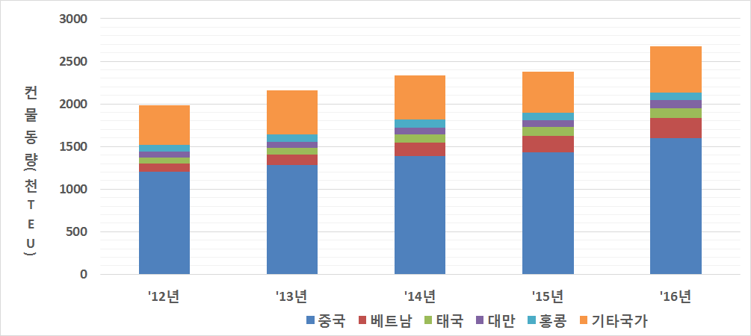

○ The top 5 countries until August this year was equivalent to other years and the increase rate of container volume to China was 19.4% and the increase rate of Vietnam was 15.9%. It increased by 10.5%, 16.8% and 3.3% for Thailand, Taiwan and Hong Kong respectively. Furthermore, the container volume with main countries in South East Asia increased by 11.7%, leading the increase in container volume of Incheon Port together with China.

○ Also, as for the Middle East route which was established in June last year, the average per voyage (container volume that is loaded and unloaded in 1 voyage) was 1,000 TEU last year but this year, it increased by 72% with approximately 1,800 TEU and even for the American route, the average container volume per voyage which was merely 600 TEU last year increased up to 1,000 TEU (70% increase) this year, indicating a consistent increase.

○ Kim Jong Gil, the director of Logistics Strategy Bureau at IPA stated that “The fact that the choices of ship-owners and forwarders had broadened following the increase of route had a positive impact on the increase of container volume” and that “Out of the 4 newly established route services this year, 3 of them are South East Asian routes and the increase rate of container volume with South East Asian countries have indicated to be high so we will continue to expand the container volume with the regions concerned”.

【Reference 1】Total August Container Volume
(Unit : TEU, %)
Item | ‘16 |  | ‘17 |  | Increase & reduction amount/rate compared to previous year
 | August | Sum | August | Sum | Same month |  | Sum
Total | 219,291 | 1,690,541 | 254,490 | 1,985,388 | 35,199 | 16.1 | 294,847 | 17.4
Import | 114,248 | 870,482 | 129,058 | 990,243 | 14,810 | 13.0 | 119,760 | 13.8
Export | 103,034 | 803,987 | 123,556 | 936,607 | 20,522 | 19.9 | 132,620 | 16.5
Trans-shipment | 1,231 | 9,684 | 1,244 | 15,146 | 13 | 1.1 | 5,462 | 56.4
Coastal | 779 | 6,389 | 633 | 43,393 | ∆146 | ∆18.8 | 37,005 | 579.2

【Reference 2】Container volume per country
(Unit : TEU, %, based on increase amount)
Item |  | Volume |  | Compared to previous year
 |  | Aug. '16 | Aug. '17 | Increase &  reduction amount | Increase & reduction rate
Total |  | 219,291 | 254,490 | 35,199 | 16.1
Increase | China | 125,841 | 152,813 | 26,972 | 21.4
 | Iran | 2,297 | 6,318 | 4,021 | 175.1
 | Thailand | 9,091 | 12,031 | 2,940 | 32.3
 | Vietnam | 21,110 | 22,326 | 1,217 | 5.8
Reduction | Taiwan | 10,400 | 9,284 | ∆1,117 | ∆10.7
 | Mexico | 719 | 101 | ∆618 | ∆86.0

【Reference 3】Incheon Port’s container volume per month
(Unit : TEU, %)
Item | 2016 | 2017 | Increase &  reduction amount | Increase & reduction rate
Jan. | 209,087 | 246,525 | 37,438 | 17.9
Feb. | 167,689 | 193,040 | 25,351 | 15.1
Mar. | 203,050 | 258,065 | 55,015 | 27.1
Apr. | 223,126 | 259,951 | 36,825 | 16.5
May | 216,813 | 254,313 | 37,500 | 17.3
Jun. | 217,994 | 257,600 | 39,606 | 18.2
Jul. | 233,492 | 261,405 | 27,913 | 12.0
Aug. | 219,291 | 254,490 | 35,199 | 16.1
Sept. | 221,727
Oct. | 251,467
Nov. | 252,521
Dec. | 263,249
Total | 2,679,504

【Reference 4】Incheon Port’s annual container volume per country
(Unit : 1,000 TEU, %)
Item | 2012 | 2013 | 2014 | 2015 | 2016 | Increase & reduction rate
Total | 1,982 | 2,161 | 2,335 | 2,377 | 2,680 | 7.8
China | 1,203 |  | 1,388 | 1,435 | 1,596 | 7.3
Vietnam | 97 | 125 | 154 | 191 | 242 | 25.6
Thailand | 72 | 78 | 97 | 105 | 108 | 10.7
Taiwan | 66 | 73 | 83 | 77 | 103 | 11.6
Hong Kong | 78 | 86 | 94 | 84 | 81 | 1.1

【Reference 5】Incheon Port’s August accumulated container volume per country
(Unit : 1,000 TEU, %)
Item | Sum of Aug. 2016 | Sum of Aug. 2017 | Increase amount | Increase rate
Total | 1,691 | 1,985 | 295 | 17.4
China | 995 | 1,189 | 193 | 19.4
Vietnam | 149 | 172 | 24 | 15.9
Thailand | 73 | 81 | 8 | 10.5
Taiwan | 63 | 74 | 11 | 16.8
Hong Kong | 54 | 55 | 2 | 3.3

--------------------------------------------------------------------------------------------------------------
ABOUT INCHEON PORT AUTHORITY(IPA)
IPA was established in 2005 as a national public service company to develop and operate port facilities and logistics centers in Incheon region more efficiently. Since its inception, IPA has made every effort to enhance the role of Incheon port as one of the global hubs in the East Asia and undertaken three major projects to meet the requirements for the role as follows:
1. Construction of a score of deep sea container terminals with 16 meters draft deep enough to accommodate 13,000TEU ships by 2017. A part of the facilities, which will be in operation with constant draft of 14 meters from June 2015 will help Incheon port to be connected to the major ports in America, Europe and the other continents with direct calls of up to 8,000 TEU ships.
2. Construction of the Incheon New Passenger Terminal to accommodate 150,000 DWT cruise ships by 2017. The construction project includes the development of Multi-functional Resort Complex which comprises shopping mall, entertainment center and resort & leisure facilities.
3. Development of logistics parks as large as 6,113,000㎡ by 2030 to support the activities of sea port as well as Incheon Airport. They will turn out as one of the most ideal logistics centers for global logistics companies with a view to their accessibility to Megacities and ports in Korea and Northern China.
for more information, visit IPA on http://www.icpa.or.kr or contact IPA Hong Kong office +852-2811-1741, icpahk@biznetvigator.com

