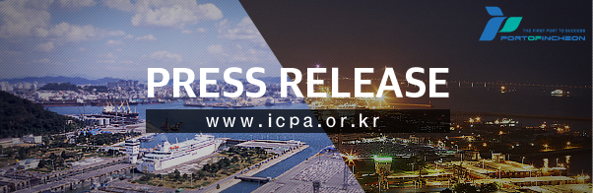
Incheon Port records highest TEU per quarter in history
\ 780,000 TEU in 3rd quarter, 15.8% increase from the same quarter in the previous year

[October 31th, 2017, Incheon, Republic of Korea]

○ Incheon Port Authority (www.icpa.or.kr, CEO Nam Bong Hyeon) revealed on the 30th that the container volume handled by Incheon Port increased by 15.8% from 675,000 TEU in the same quarter last year to 781,000 TEU.

○ This is the highest number in the quarterly container volume handled in the history of Incheon Port and has set a new record after achieving 700,000 TEU in the 4th quarter last year. This year’s cumulative container volume is 2.251 million TEU.

○ According to Incheon Port Authority, out of the total cargo volume in the 3rd quarter of Incheon Port, import cargo took up 50.4% with 393,000 TEU, an increase of 45,000 TEU (12.9%) from the same quarter in the previous year. As for export, it was 381,000 TEU, an increase of 61,000 TEU (19.1%) from the same quarter in the previous year. As for transshipment and coastal cargo volume, it recorded 4,743TEU (25.0%) and 1,907TEU (△16.4%) respectively.

○ Per country, volume to China (470,114 TEU) increased by 19.6% (77,163TEU) and volume to Thailand (35,191 TEU) increased by 39.7% (9,995 TEU). Volume to Iran (11,821 TEU) experienced an increase in the volume since the establishment of the Middle Eastern Route service in June last year, showing a 94.9% (5,756 TEU) increase.

○ On the other hand, Incheon Port’s container volume last month recorded the highest in the September volume in history with 265,134 TEU which is a 19.6% increase from 221,727 TEU last year. The long festive season, Chuseok, at the beginning of October leading to early shipment seems to be the cause for higher volume in September this year compared to the predicted volume.

○ Kim Jong Gil, the director of Incheon Port’s Logistics Strategy Bureau stated that “the cargo volume to the Chinese port would continue to take up the highest share in the future but the cargo volume of South East Asia is expected to rise continuously” and that “in the future, we will strive to satisfy the needs of forwarders of import and export by diversifying the routes through the expansion of coast line services in not only South East Asia but also in the America region.”

< Other analytic materials: Centered on Incheon Port >

○ In the past 5 years, in terms of the annual cargo volume scale of Incheon Port per foreign port, the top 5 ports were all ports in China, Shanghai Port, Qingdao Port, Weihai Port, Shekou Port and Dalian Port. As for Shanghai Port, there was a 10.5% increase in the annual average from 201,000 TEU in 2012 to 300,000 TEU in 2016. Followed by Qingdao Port with a 6.2% increase in the annual average from 214,000 TEU in 2012 to 272,000 TEU in 2016.
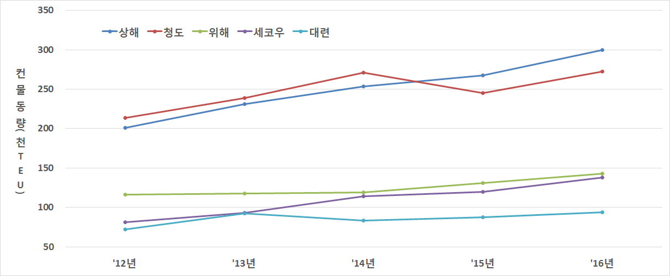

○ As of the cargo volume until September this year, the top 5 ports were Shanghai Port, Qingdao Port, Weihai Port, Shekou Port and Haiphong Port. Shanghai Port recorded 257,000 TEU, a 44,000 TEU increase from the same quarter in the previous year, maintaining its position as the biggest trading port of Incheon Port and Qingdao Port showed the biggest increase rate of 26.6% out of the top 5 ports with 242,000 TEU. As for Haiphong Port, Vietnam, there was a 26.1% increase rate in cargo volume from 85,000 TEU to 107,000 TEU in September’s cumulative last year.

○ In addition, as for the top 5 ports in terms of increase rate of annual cargo volume to overseas ports above 100,000 TEU of cumulative cargo volume in the past 5 years, Haiphong Port, Ningbo Port, Ho Chi Minh Port, Bangkok Port and Kaohsiung Port, indicating a strength in South East Asian port. Haiphong Port (Vietnam) showed an increase rate of 30.4% in the annual average from 42,000 TEU in 2012 to 122,000 TEU in 2016. Followed by Ningbo Port (China), it showed an increase rate of 19.8% in the annual average from 52,000 EU in 2012 to 107,000 TEU in 2016. Ho Chi Minh (Vietnam), Bangkok (Thailand) and Kaohsiung Port (Taiwan) recorded an increase rate of 18.8%, 17.9%, and 14.7% respective in the annual average.

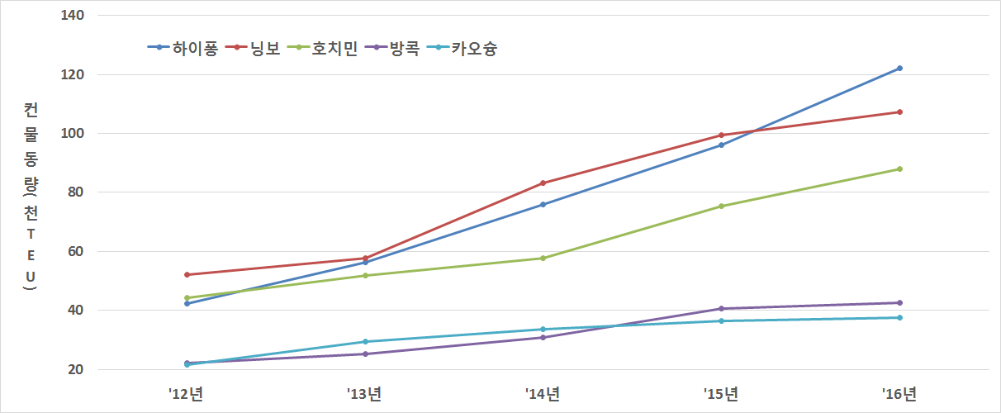

<Reference> Statistics table such as current status of cargo volume and others

【Reference 1】 Total container volume in September (Unit: TEU, %)
Item | 2016 |  | 2017 |  | Increase and decrease amount compared to previous year/rate
 | Sept. | Cumulative | Sept. | Cumulative | Same month |  | Cumulative
Total | 221,727 | 1,912,268 | 265,134 | 2,250,682 | 43,407 | 19.6 | 338,414 | 17.7
Import | 116,398 | 986,880 | 134,221 | 1,124,465 | 17,823 | 15.3 | 137,585 | 13.9
Export | 103,343 | 907,329 | 128,635 | 1,065,400 | 25,292 | 24.5 | 158,071 | 17.4
Trans-  shipment | 1,296 | 10,980 | 1,663 | 16,809 | 367 | 28.3 | 5,829 | 53.1
Coast | 691 | 7,079 | 615 | 44,008 | △76 | △11.0 | 36,929 | 521.7

【Reference 2】 Container volume per import and export in 3rd quarter (Unit: TEU, %)
Item | Cargo volume |  | Compared to previous year
 | 3rd quarter in 2016 | 3rd quarter in 2017 | Increase and decrease amount | Increase and decrease amount
Total | 674,509 | 781,036 | 106,527 | 15.8
Import | 348,529 | 393,375 | 44,846 | 12.9
Export | 319,908 | 381,011 | 61,104 | 19.1
Transshipment | 3,793 | 4,743 | 950 | 25.0
Coast | 2,280 | 1,907 | △373 | △16.4

【Reference 3】 Container volume per country in the 3rd quarter (Unit: TEU, %, based on increase and decrease amount)
Item |  | Cargo volume |  | Compared to previous year
 |  | 3rd quarter in 2016 | 3rd quarter in 2017 | Increase and decrease amount | Increase and decrease amount
Total |  | 674,509 | 781,036 | 106,527 | 15.8
Increase | China | 392,951 | 470,114 | 77,163 | 19.6
 | Thailand | 25,196 | 35,191 | 9,995 | 39.7
 | Iran | 6,065 | 11,821 | 5,756 | 94.9
 | Vietnam | 64,932 | 68,767 | 3,836 | 5.9
Decrease | Taiwan | 29,933 | 27,227 | △2,707 | △9.0
 | Mexico | 2,113 | 670 | △1,443 | △68.3

【Reference 4】 Container volume per annual quarterly term (Unit: 1,000 TEU, %)
Item | 2014 | 2015 | 2016 | 2017
Total | 2,335 | 2,377 | 2,680
1st quarter | 521 | 539 | 580 | 698
2nd quarter | 604 | 599 | 658 | 772
3rd quarter | 603 | 602 | 675 | 781
4th quarter | 606 | 638 | 767

【Reference 5】 Top10 overseas port in terms of cargo volume in 5 years
(Unit: 1,000TEU, %)
Item | 2012 | 2013 | 2014 | 2015 | 2016 | Average increase and decrease rate
Shanghai | 201 | 231 | 254 | 268 | 300 | 10.5
Qingdao | 214 | 239 | 271 | 245 | 272 | 6.2
Weihai | 116 | 118 | 119 | 131 | 143 | 5.2
Shekou | 81 | 93 | 114 | 120 | 138 | 14.2
Dalian | 72 | 92 | 83 | 87 | 94 | 6.9
Hong Kong | 78 | 86 | 94 | 84 | 81 | 1.1
Ningbo | 52 | 58 | 83 | 99 | 107 | 19.8
Haiphong | 42 | 56 | 76 | 96 | 122 | 30.4
Tianjin | 91 | 66 | 58 | 80 | 92 | 0.3
Yantai | 62 | 65 | 73 | 70 | 76 | 5.2

【Reference 6】 Top 10 overseas port for cumulative cargo volume in September 2017
(Unit: 1,000TEU, %)
Item | Cumulative in Sept. 2016 | Cumulative in Sept. 2017 | Increase Amount | Increase rate
Shanghai | 212 | 257 | 44 | 20.9
Qingdao | 191 | 242 | 51 | 26.6
Shekou | 99 | 115 | 16 | 16.0
Weihai | 99 | 115 | 15 | 15.4
Haiphong | 85 | 107 | 22 | 26.1
Ningbo | 77 | 106 | 29 | 38.3
Tianjin | 66 | 81 | 15 | 22.6
Dalian | 64 | 74 | 10 | 16.0
Ho Chi Minh | 63 | 67 | 4 | 5.5
Hong Kong | 59 | 64 | 4 | 7.2

【Reference 7】 Top 10 overseas port for increase rate of cargo volume in the past 5 years
(Unit: 1,000TEU, %)
Item | 2012 | 2013 | 2014 | 2015 | 2016 | Average increase and decrease rate
Haiphong | 42 | 56 | 76 | 96 | 122 | 30.4
Ningbo | 52 | 58 | 83 | 99 | 107 | 19.8
Ho Chi Minh | 44 | 52 | 58 | 75 | 88 | 18.8
Bangkok | 22 | 25 | 31 | 41 | 43 | 17.9
Kaohsung | 22 | 29 | 34 | 37 | 38 | 14.7
Shekou | 81 | 93 | 114 | 120 | 138 | 14.2
Shanghai | 201 | 231 | 254 | 268 | 300 | 10.5
Port Klang | 25 | 36 | 37 | 34 | 37 | 9.6
Qinhuangdao | 26 | 30 | 39 | 33 | 35 | 7.6
Shidao | 43 | 47 | 51 | 47 | 56 | 7.1
Note) Ports with cumulative cargo volume of above 100,000 TEU in the past 5 years

--------------------------------------------------------------------------------------------------------------
ABOUT INCHEON PORT AUTHORITY(IPA)
IPA was established in 2005 as a national public service company to develop and operate port facilities and logistics centers in Incheon region more efficiently. Since its inception, IPA has made every effort to enhance the role of Incheon port as one of the global hubs in the East Asia and undertaken three major projects to meet the requirements for the role as follows:
1. Construction of a score of deep sea container terminals with 16 meters draft deep enough to accommodate 13,000TEU ships by 2017. A part of the facilities, which will be in operation with constant draft of 14 meters from June 2015 will help Incheon port to be connected to the major ports in America, Europe and the other continents with direct calls of up to 8,000 TEU ships.
2. Construction of the Incheon New Passenger Terminal to accommodate 150,000 DWT cruise ships by 2017. The construction project includes the development of Multi-functional Resort Complex which comprises shopping mall, entertainment center and resort & leisure facilities.
3. Development of logistics parks as large as 6,113,000㎡ by 2030 to support the activities of sea port as well as Incheon Airport. They will turn out as one of the most ideal logistics centers for global logistics companies with a view to their accessibility to Megacities and ports in Korea and Northern China.
for more information, visit IPA on http://www.icpa.or.kr or contact IPA Hong Kong office +852-2811-1741, icpahk@biznetvigator.com

